

**PNEUMATIC OTOMATIC CONTROL SYSTEMS FOR KILN ROTARIES**

**BUILDING BRICK MACHINE**

**USAGE INFO**

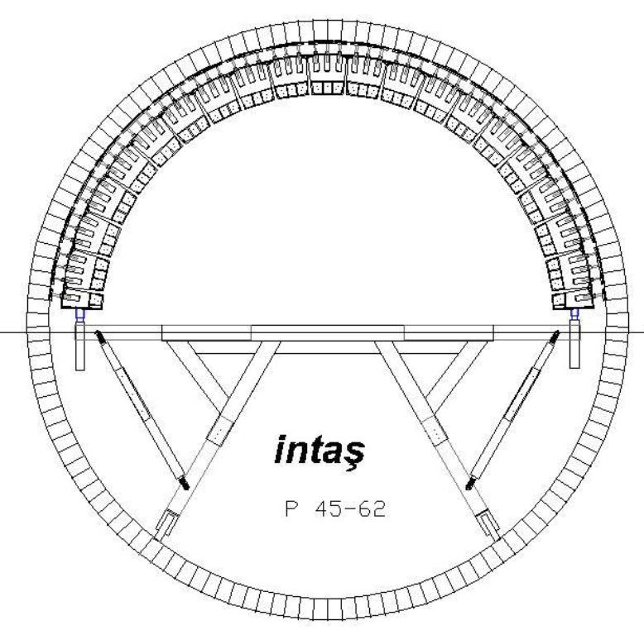

**TEL : 0342 235 24 50 – PBX Tic. Sicil No:22023/21605 Örnek Sanayi Sitesi**

**FAX: 0342 235 36 09 6.Nolu Cad. No:15**

**27110-GAZİANTEP / TÜRKİYE**

**USAGE INFO** 

The machine's sloping center can adapt to several kinds of kiln diameters with a frame adjustion. Removing or adding the circular segments around it can help adjust the kinds of kiln diameters.

In the pictures you can see the brick installation for kilns with pneumatic systems. The main ring moves forward and back on the working platform. When the circular ring working platform is over, the whole platform would have moved forward in a vertical way. Afterwards, the circular ring movement starts again beginning from the front side of the platform.

The kiln brick installation system is diagonal and circular. With the help of a letter jack, you can tighten the bricks and hammer the lock plate so that you can finish building bricks.

The lock plates can support the system and this way you can get rid of the built bricks by them moving forward.When the hydraulic letter jack needs to be pulled in order to put the brick in its place, the second ring on the back functions as a backing.So in a new building a brick usage the moving ring functions.

In the pneumatic system, the ring is equipped with individual segments and pneumatic cylinders.The segments on the top are put together with 4 bolts.There are some adjusting sticks on the below parts of the machine in order to adjust the kiln diameter.The ring is connected to the below trolley with an adaptable gage.The height adjustment of the working platform can be made through the holes in the bracket feet.

A brick building machine is designed in order to be used in different kind of kilns.The machine is designed with these diameters for the biggest and the smallest kinds of diameters.

T YPE P 30 / 36 3000 – 3600 mm

T YPE P 38 / 46 3800 – 4600 mm

T YPE P 40 / 52 4000 – 52000 mm

T YPE P 45 / 60 4500 – 6000 mm

The diameter adjustment of the machine can be done according to kiln diameter- the height of 2 bricks- 80.mm x 2.- the movements of the pistons- 100 mm.For instance: A kiln diameter of 4600.mm's brick height 200.mm 4600-400-160-100= 660 the machine diameter is approximately 3,940 mm.

THE PERFORMANCE

In order to install the brick machine into the kiln you need 2 hours.The machine is sent to you unbuilt.For a perfect operation ability there is a need of a short practical time.For building, 4-5 components are enough. The adjusting of the ring to another diameter can take 1-2 hours.

**( 1 )**

**1**



3 to 6 people can work as staff during the installation according to the kiln size.The same number of people is needed in order to build the below part of the kiln.

While the building brick method is used the linear propagation rate is estimated to be 2 to 7 square meters in an hour.Of course this fact is dependent on many factors. For example, the staff's experience and speed, the quality of the brick, its shape, its size, the method of installation (with soil mixture or dry) the peripherals of the kiln and the supplying of the bricks etc.

4,6 m diameter kiln of 200 mm height if the magnesite brick is used according to the ISO standard can build 6 m2 per hour in 25-30 mins.

The main parts of the machine :

* The movable ring
* The movement centers with pneumatic cylinders

1. The main parts of the movable console

- 2 welded special alloy aluminum tube and product console from the pieces.The angular support, an enlargeable piece that provides the movement and in the last part a wheel with balls and gray cast iron body.These wheels have diameters of 300 mm and the wheel for is made of GS. 50 materials for security purposes.These wheels are equipped with brakes.

- 2 connection elements are made of a rectangular shape.- 2 ring moving rails are made of shape.

- 6adjusting and supporting elements 50x90 shape.

- 1 platform enlargement balcony

- 1 set (front and back) guards with lights

- 1 ladder

- 1 set of a working platform and for the balcony part wainscoting woods

B) Middle center

The front consists of a movable working group and the back consists of a supporting center.

1 middle piece consists of 5 to 7 pairs of segments changeable according to the type of machine.

2 ring carriers and cars that slope 2 wheels with balls each

**( 2 )**

2



C)Pneumatic equipment

* 1 Set of 40 Ø x 160 mm cylinders and a cylinder connected with 4/2 type valve.

There are colored air tubes in the dividable center's parting places and the connection is made through jacks.

- 1 air tube and oiler, there is pressure adjustment tool on the filter.In the entrance of the filter there is a security jack, air tanks, connection elements and air entrance fitting items (male, female) in the whole air supplying unit of 8 or 10 mms supplied by the customer.

D) Electricity equipment

2 220 volt 500 watt projector lamp is present and the cable and plugs are supplied by the customer.

E) Accessories

- 1 Hydraulic press

- 1 hydraulic hand pomp with pressure manometer ( Air compressor with pressure is going to be provided by the company.)

- 1 set of hand tools for the installation

- 1 set of spare bolts, nuts, pins (3 or 5 for each kind)

**BRICK BUILDING MACHINE INSTALLATION INSTRUCTIONS**

1.First steps

Before the installation, the kiln should do a brick building surrounding a 3.4 m height and 55% of the periphere.Afterwards the machine can be put into the kiln.

The undercoating being done inwards can prevent the brick from dissolving and moving down. The brick is installed in a correct peripheral way. You can start from the segments at the exit of the kiln or the fulcrum ring.Radial welding spots can help you during the installation.

In the brick building, there is a need of a qualified person who knows about the kiln brick installation and 4 additional people to help.

Machine is given to you with the prepared parts.The controlling of the pieces after them being put together according to the instructions can save you from a wrong adjustment and damaging the machine.

**( 3 )**

**3**



Before the usage, the hydraulic letter jack may need to be tried out with some hydraulic oil.

Oil types to use:

|  |  |  |
| --- | --- | --- |
| **SHELL** | **BP** | **MOBILE** |
| **TELLUS T 15** | **ENERGOL SHF HV 15** | **DTE 11 M** |

For the air oiling with pressure more oil is needed.The oil level should be controlled.

Oil types to use:

|  |  |  |
| --- | --- | --- |
| **SHELL** | **BP** | **MOBILE** |
| **TELLUS T 15** | **ENERGOL SHF HV 15** | **DTE 11 M** |

2. The installation of the brick

2.1. RING trolley

In Picture 1, according to the picture the carrying console's installation should be done outside the kiln.First, you need to mark the tubes according to the kiln diameter. In case of any doubt,the legs could be moved out and the consoles upper ending could be put in the middle of the kiln.Console can be put together and put 3,5 m near the kiln, so that the connecting pieces can come together.

Afterwards, consoles can be screwed down to the side carrying beams according to the plan in the picture 2 when they are put together.

The sideways carrying rails can be adjusted according to the picture 1 after the measuring of it. For this measurement there are marks on every pushed tubes for every diameter and this is organized when the machine is delivered.

In case of any doubt, the linear tubes can be made longer and moved to the side carrying beam that is in 10 cm distance of the brick..

The linear tube and the carrying trolley's feet should be the same length as the other side.(Same number of holes) The adjustable, cross supports diagonal cross sections and the enlarged balcony should be hung after being organized according to picture 2.After that, the balcony should be closed with some thick wood. The balcony enlargement points should be regulated according to the working direction and put to the every side of the kiln installation machine. So there are no additional preparation for the trolleys.And then the guardrails with lights can be put also.Important  **:** When the brick process is being done, big carrying platform wheels and the ring wheels' brake bolts is tightened.The building process is continued. 2.2. Center 5 or 7 middle segment groups should be marked unseperately according to the kiln diameter during the delivery.In case of doubt, the center height can be determined outside the brick approximately 80 mm with a trolley.

**( 4 )**



The radius of the center is determined according to the picture 3.There needs to be a connecting piece for every diameter.Picture 4 shows the segments and how they are distributed.

According to the picture 3 and 4 after the installation of the center the trolley waits near with it's bolts loose.The part where the trolley is should be moved up and the trolley should be pushed to the carrying part.This should be done for both sides.

Picture 4 shows the air connection.In case of the individual segments being put together the connection parts should be in accord with each other

When the air pipe is connected the piston moves the kiln brick up.The picture 6 shows the air pressure.There must be enough oil in the air oiling part. The air filter should be clean at all times.We should not store excessive amounts of water.The air pressure should be 5 to 7 bars.

The center's pieces are on the working side.The individiual working of the cylinders are shown on picture 5.The front center's all cylinders and the back center's middle cylinders are shown in the picture. The cylinders that belong to the back are controlled with 2 air providing tubes and 2 main valves in order for it to work practically.They work as backing cylinders not working cylinders.

The centering of the center's side, or the shell around the kiln being adjusted is done through tubes pushed in a linear way or the moving of the trolley.

In order to move the center to the kiln's top part for them to be equally distanced from each other you can move the platform up and down.If there are no forklifts the work platform can be moved up and down with the central hydraulic press and there can be a plate iron under the console in the harmony space.

**3. The working of the brick building of the machine**

The machine is designed in a way that it can process from the center backwards.The front center is the working center.The bricks are put in a row in the ground.After every lifting, the tightening is done through hammering the brick with a rubber hammer.As it says above it's important for the welded points to be parallel to the installation ring.

This helps marking every meter of the brick building.If it's not parallel it should be corrected on the ring before starting.

**( 5 )**



Brick is tightened with a hydraulic press after the middle segments are openly put to the right and left sides.When the built bricks do not move onwards the cylinders go down.Because of the tightening with a letter jack, the built bricks function as a support.

And then the supporting center( back center) The brick row that isn't closed yet and the support segments are aligned and the putting up is done with 2 valves.Afterwards, the hydraulic press is moved backwards and the bricks are put to their places with 3 individual cylinders of the back.

The new brick row starts from the front center.

4. General aims

2 tons of weight can be put between 2 connecting parts.The weight should not excess 1 ton per meter square.

The balcony part can have 300 kgs and between the trolley and connection parts there can be 500 kgs. The brick building machine, should don't excess 3 tons including the staff.

During the movement in the kiln the front part and the console's ending should be put straight. The big trolley's wheels should be done right according to the picture 7 a.If the building machine is moved in a wrong way you can correct it by turning the wheels.The balance can be adjusted according to the water scales that are on the carrying consoles.

After the usage the machine should be cleaned right away.Before putting it in a box you should control if the parts are all there.This way you will not have any problems when you have to use again.There is no special maintenance for the air oiling system and while putting oil to the hydraulic press.Because the center and the working platform is not that fast the machine can work for years after the oiling of the wheels.

**( 6 )**